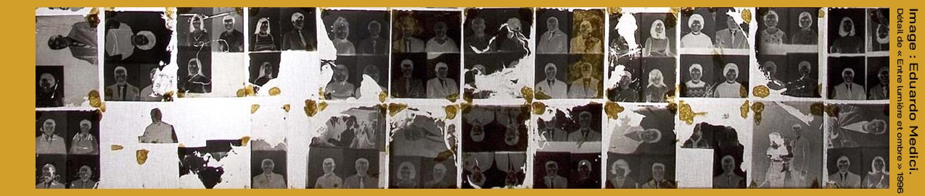

DEM’ARTS: Creation, democracy and digital media

2nd cycle of cross-disciplinary seminars

2025-2026

Presentation
The DEM'ARTS project of University Paris 1 Panthéon-Sorbonne is dedicated to the relationship between the arts and democracy through the prism of pragmatism and new technologies. For its second cycle of seminars, DEM'ARTS is continuing its activities and research, focusing primarily on the relationship between creation, democracy, and artificial intelligence. Following an opening session by the project team, which focused on the sensory, aesthetic, and social transformations brought by AI and their influence on artistic practices and the circulation of knowledge, this new cycle continues to explore how emerging technologies are reshaping our relationship with creativity and with others in society.
Over the course of the seminars, the various themes explored will examine how AI can reshape our ideas of humanity and alterity, influence the collective imagination, and challenge the responsibilities associated with creative practices and artistic experiences. The seminars will address the critical and political issues raised by these changes, whether they concern identity, colonialism, or new forms of influence in the cultural industries or in the everyday use of automation technologies.
These debates will provide an opportunity to discuss more broadly the transformations in artistic and musical practices in the age of algorithms, as well as their influence on creativity and the dissemination of artistic productions. The cycle will also pay particular attention to educational issues, conditions of access to knowledge, and forms of democratic participation that these developments may bring into play.

Program

- October 14, 2025 (6-8 p.m.)

DEM'ARTS group seminar: Miguel Almiron, Aurélie Herbet, Barbara Formis, Sandra Laugier, Azadeh Nilchiani, and Camille Salinesi
“AI and Sensitive Transformations of Democracy”

- December 9, 2025 (6-8 p.m.)
Gwenola Wagon. Professor/Artist, ACTE Institute, Paris 1 Panthéon-Sorbonne University. Moderator : Barbara Formis PR (ACTE)
“I am not a robot”

- February 17, 2026 (6-8 p.m.)

Ada Ackerman. Researcher at CNRS, THALIM-Theory and History of Modern Arts and Literature. Moderator: Camille Salinesi PR (CRI)
“Decolonial Potentials of AI?”

- March 10, 2026 (6-8 p.m.)

Esteban Buch. Musicologist at the Ecole des Hautes Etudes en Sciences Sociales (EHESS) Paris, Center for Research on the Arts and Language (CRAL). Moderator: Azadeh Nilchiani Postdoc DEM'ARTS
“The Power of Music in the Age of Streaming”

- March 27, 2026 (6-8 p.m.)

Francesca Ferrando. Philosopher, professor at New York University (NYU)
Moderator: Miguel Almiron PR (ACTE)
“The Art of Being Posthuman”

- April 7, 2026 (6-8 p.m.)

Philippe Codognet. Professor at Sorbonne University, Director of the Franco-Japanese Computer Science Laboratory, IRL CNRS Research Center, Japan.
Moderator: Sandra Laugier PR (ISJPS)
“The reality of the virtual and the virtuality of the real”

- May 12, 2026 (6-8 p.m.)

Joanna Zylinska. Artist, writer, curator and Professor of Media Philosophy + Critical Digital Practice at King’s College London. Moderator: Azadeh Nilchiani Postdoc DEM'ARTS
“Creativity and Art Beyond the Human Exception”

Scientific team

Responsible for the program : Sandra Laugier, professor of philosophy (ISJPS).
Project board : Miguel Almiron PR, Barbara Formis MCF HDR, Aurélie Herbet MCF and Yann Toma PR (ACTE), Philippe Codognet (JFLI - CNRS), Camille Salinesi PR (CRI) and Azadeh Nilchiani post-doctoral researcher, Université Paris 1 Panthéon-Sorbonne.

Venue and information
- Venue: Room 216 of the Panthéon Center at 12 Place du Panthéon, 75005 Paris, and certain sessions will be held via Zoom.
- Hours: 6-8 p.m. Paris time.
- Public: The seminar is open to researchers, artists, and students.
>>> Registration is required for participants from outside Paris 1 University, via this link: https://demarts.pantheonsorbonne.fr/seminaire-transversal/inscription-seminaire

